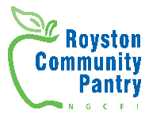
Royston Community Pantry
Membership Form

Name
Address
Postcode
Email address
Contact Number

What is your gender?
Male | Female | Other | Prefer not to say

How many people live in your household?
Adults | Children

What is your age group?
16-24 | 25-44 | 45-59 | 60-64 | 65-74 | 75 +

What is your current employment situation?
Working | Universal Credit | Pensioned | Asylum seeker | Other, please state:

Do you or anyone in your household consider yourself to have a disability? (A physical or mental impairment, which has a substantial long-term effect on your ability to carry out everyday activities):
Yes | No | Prefer not to say

Before accessing the pantry, how would you rate the quality of your diet?
Very poor | Poor | Average | Good | Very good

How many portions of Fruit and Veg do you eat a day?
0 | 1 | 2 | 3 | 4 | 5 | 5+

Would you be interested in being involved in the running of the pantry?
Yes | No

Would you like to become a member of North Glasgow Community Food Initiative? It’s free and you can help influence what we do through annual meetings, consultation events or sending us your ideas and suggestions at any time.
Yes | No

Do you worry about heating your home? Tick this box if you would like us to pass on your details to Home Energy Scotland, a government organisation for free advice and support.
Yes, please share my details | No, I do not want to be contacted

In signing this form, I confirm that the above information is correct and consent to my information being used by relevant people within Royston Community Pantry. As part of the requirements of GDPR, the following data applies to the data submitted on this form. Royston Community Pantry collects and stores this data for the purpose of monitoring and providing effective support to users of Royston Community Pantry. This data is held securely and will not be shared with any person or agency without your permission or based on legitimate interest.

Signed: Date:

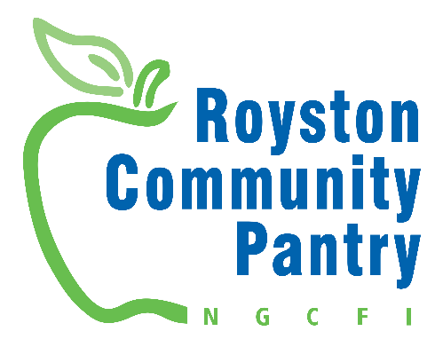
Royston Community Pantry
Terms and Conditions

Eligibility
- Membership to Royston Community Pantry is open to anyone who would like to join.
- Membership is restricted to one per household.
- Proof of address (e.g. a utility bill) and a form of ID (e.g. passport or driving licence is required when applying. If you don’t have these, get in contact to discuss other options.
- All members must pay the annual membership fee and a further fee at each visit.
- Royston Community Pantry reserves the right to change fees as required, though will give good notice of upcoming changes online and in signage in the pantry.

Policies
- Each member is entitled to one visit per week.
- Only one of each item can be taken to ensure that there is a good selection of produce for everyone.
- Members must be present at visit or have one representative per household for those with reduced mobility. This needs to be discussed with the Royston Community Pantry staff and supported with a signed letter.
- A colour code system will be in effect to indicate different categories of goods e.g. dry goods, fresh fruit and veg, toiletries etc and how many items per category members are entitled to.
- Royston Community Pantry reserves the right to cancel or refuse any membership at any time. This may happen if you are found to breach any of these policies, or are abusive towards staff, volunteers, or customers.
- Members must present the membership card at each visit.
- Members must not resell items taken from the pantry. If this happens, membership will be terminated immediately.
- Pantry stock may vary from week to week. Royston Community Pantry cannot guarantee the availability of any item.
- Royston Community Pantry has a limited number of memberships. If you are unable to get a membership, we will operate a waiting list and will contact you as soon as a membership becomes available.
- Members must bring their own bags; no bags will be provided by the pantry.

I agree to abide by the terms and conditions listed above:

Signed: Date:

