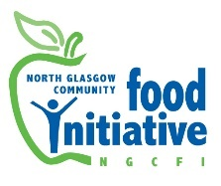

St Andrew's Church

Liddesdale Square, Milton

Glasgow, G22 7BT

Tel 0141 772 0229

Office Mobile: 07422 375523

Email: **admin@ngcfi.org.uk**

www.ngcfi.org.uk

Charity No SCO36842

Company Reg No 290958

**Dear Applicant*,***

**Vacancy: Sessional Cook**

Thank you for your interest in this post at North Glasgow Community Food Initiative

You should have received the following papers with web site download: Job Description and Person Specification

Application: Applicants will be required to outline in a cover letter, by referring to the job description and specification, their relevant experience, qualifications and information as to why they believe they are the right person for the post. Applicants will also be required to attach a CV.

* Cover letter format: No more than 1 side of A4 paper.
* Applications should be made via email and marked ‘Sessional Cook Application’ and emailed to **admin@ngcfi.org.uk**
* Deadline: **12pm on Monday 16th August 2023**
* Interviews: **Wednesday 23rd August 2023**

If, due to childcare commitments or similar, you are unable to make the allotted interview time, please let us know as soon as possible. We will do our best to accommodate all reasonable requests. If you have not heard within a few weeks of the closing date you may assume that on this occasion you have not been successful in being invited for interview.

**Equal Opportunities**

As an organisation we are committed to equal opportunities and encourage applications from all sectors of the community. Please call the office if you would like a copy of our equal opportunities policy. We guarantee an interview to anyone who meets the minimum requirements. Please don’t hesitate to contact our office should you require further information.

Best Wishes

Martha Wardrop

Chairperson of the Board of Directors

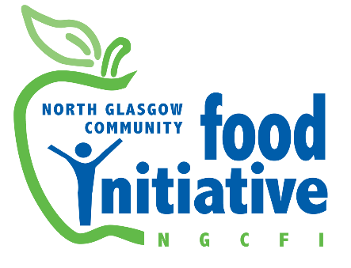

**Job Description**

**Sessional Cook (Flexible working)**

**Responsible to** Food Hub Managers

**Hourly rate**: £18 per hour

## Hours: 20 weeks x 8 hours per week. Additional flexible working available.

**Work Base:** Royston, Springburn, Milton

**Job Purpose:**

As a sessional cook you will be required to work flexibly to suit the needs of the participants and NGCFI at anyone of our Food Hubs or other locations. You will be proficient at delivering cookery courses aimed at improving the health and wellbeing of local residents to a high standard, focused on healthier eating and cooking skills as well as bringing in cooking traditions from different cultures. Inputs on Food Waste, cooking on a budget are also required. Recipes are provided. Classes can be day time or evening, occasionally weekends.

**The main duties are:**

1. **Planning and preparation**

* Source the ingredients, using fruit and veg from NGCFI - produce and / or edible food waste / FareShare were possible.
* Preparing or using existing recipe/information sheets

1. **Delivering the weekly classes / workshops for agreed number of weeks**

- Picking up equipment for the session from the store in our unit and returning same clean. Storing items carefully. Keeping store room tidy.

- Setting up the sessions with awareness of potential risks

- Encouraging participants to try healthy food and promote healthy eating within the home

- Preparing for and clearing up after the group meetings

- Facilitating the sessions, including registration, start and end of courser monitoring

- Draw upon a common ingredients basket which can be used at home.

- Ensuring that basic food hygiene procedures are followed

1. **On-going admin and preparation**

* Keep receipts for all expenditure and submit them to the named staff member who will reimburse them, usually paid by BACS.
* Keep a track of the budget for each session (for ingredients)

- Complete monthly time sheets for work undertaken and submit them to the named staff member or Project Manager by 14th of the month. Payment is on last Thursday of the month.

- Keep records of attendance and participant details forms and make reminders to participants for the next session

- Provide recipes each session and collated at the end of the course.

- Liaising with and support any volunteers involved in the sessions

4. **Health and Safety, Liaison and Learning**

- Comply with health and safety policies and procedures

- Support for and liaison with volunteer(s)

- Liaison with other NGCFI staff who may attend or support sessions

- Liaise with partner staff in respect good communication and delivery

- To be Health and safety aware and undertake risk assessments as required, adhering to same, to minimise risk in all areas of your work.

- Participate in learning opportunities including sessional worker meetings and post course de-briefs.

- Participate in support sessions (individual or group).

- Adhere to NGCFI policies and procedures

5. **Monitoring and Evaluation**

- You will be responsible for the return of start / end feedback sheets and other feedback information as required such as equalities monitoring forms. Write up an evaluation of the sessions. Final Payment may be withheld until paper work is submitted.

6. To undertake other duties appropriate to the post in support of the organisation’s smooth functioning.The above is subject to review from time to time.

**PERSON SPECIFICATION CRITERIA**

**In applying for this post describe how you meet each of the essential criteria.**

|  |  |
| --- | --- |
| **ESSENTIAL** | **DESIRABLE** |
| **Values, Qualifications or Experience** | |
| An interest in and desire to work towards the Vision, Mission and Aims of NGCFI, including a commitment to healthy diet and living. | Qualification or suitable relevant experience in food and nutrition |
| Experience of and proficient in delivering healthier eating cookery classes | Elementary Food & Health Certificate  Emergency First Aider Certificate |
| Elementary Food Hygiene Certificate |  |
| **Community Food and Health** | |
| Well organised with an ability plan and deliver cookery classes enthusiastically, focused on healthy eating and sharing cooking skills to young people or adults, including asylum seekers. | Experience of supporting people with higher support needs eg: those with learning difficulties or mental health issues |
| Ability to respect individuals and during delivery encourage their interest in food related aspects of their lives. | Awareness and understanding of community food and health issues |
| **Communication** | |
| Good verbal communications skills and ability to communicate effectively with a diverse range of people. | Supporting volunteers |
| Competent in MS of Word |  |
| **Other** | |
| Experience of using and working within appropriate protocols and procedures e.g. health and safety, risk assessments | Experience of monitoring and evaluation. |
| Ability to work on own initiative and as part of a team. |  |
| Clean driving license and access to a car |  |
| Willingness to undergo PVG check |  |