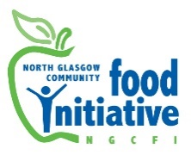
St Andrew's Church
Liddesdale Square, Milton
Glasgow, G22 7BT

Tel 0141 772 0229
Office Mobile: 07422 375523
Email: admin@ngcfi.org.uk
www.ngcfi.org.uk

Charity No SCO36842
Company Reg No 290958

Dear Applicant,

Vacancy: Sessional Youth Gardener

Thank you for your interest in this post at North Glasgow Community Food Initiative

You should have received the following papers with web site download: Job Description and Person Specification
Application: Applicants will be required to outline in a cover letter, by referring to the job description and specification, their relevant experience, qualifications and information as to why they believe they are the right person for the post. Applicants will also be required to attach a CV.
- Cover letter format: No more than 1 side of A4 paper.
- Applications should be made via email and marked ‘Sessional Youth Gardener Application’ and emailed to admin@ngcfi.org.uk
- Deadline: 12pm on Monday 16th August 2023
- Interviews: Wednesday 23rd August 2023

If, due to childcare commitments or similar, you are unable to make the allotted interview time, please let us know as soon as possible. We will do our best to accommodate all reasonable requests. If you have not heard within a few weeks of the closing date you may assume that on this occasion you have not been successful in being invited for interview.

Equal Opportunities
As an organisation we are committed to equal opportunities and encourage applications from all sectors of the community. Please call the office if you would like a copy of our equal opportunities policy. We guarantee an interview to anyone who meets the minimum requirements. Please don’t hesitate to contact our office should you require further information.

Best Wishes

Martha Wardrop
Chairperson of the Board of Directors

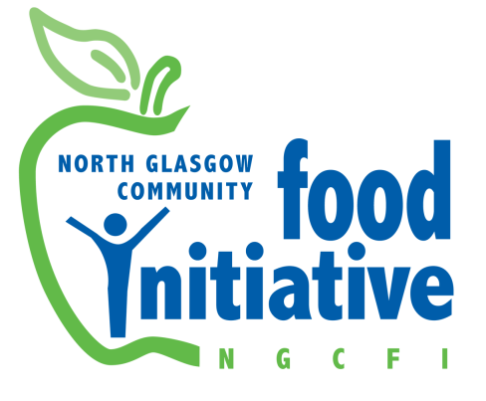
Job Title: Sessional Youth Gardener

Employer: North Glasgow Community Food Initiative

Hourly rate: £18 per hour

Hours: As required. Need to be flexible with working hours as some of the work is seasonal. Early evening and weekend working may be required.
Responsible to: NGCFI Royston Food Hub Manager
Work Base: Royston, Springburn, Milton
Job Purpose:

You will be skilled in local food growing/ gardening/ agriculture and able to assist in the planning and delivery of youth gardening activities. Within a context of a communities living with significant socio-economic deprivation you will be able to enthuse and actively engage young people in outdoor play, growing fruit and vegetables and learn about the food cycle, to improve physical activity, health and wellbeing. For the most part, you will be working with children aged between 3 and 12 years old. You will also be required to work alongside volunteers. There is also possibility of related partnership working with a local housing association and nurseries in the area

Duties of sessional gardeners include (to be finalised with a responsible staff member, depending on area of involvement):

- Support and engage young people in growing and outdoor learning activities
- To engage young people in developing their skills and experience relating to the local environment, the food cycle, food production, food waste, healthy eating and living; and encouraging enjoyable physical activity of growing-your-own fruit and vegetables at our growing sites, in local communities and/or schools.
- To have good working relationships with our partners, including school teachers accompanying pupils.

- Practice community-led and person-centred methodologies where possible:
- To take account of volunteers and participants in planning and delivery.
- To foster the development of leadership roles for volunteers and participants in pursuit of the gardening projects aims, and encourage participation in decision making and the respective Food Hub Group.

- Resourcing materials & timesheets:
- Keep receipts for all expenditure and submit them to the named staff member who will reimburse them, usually paid by BACS.
- Keep a track of the budget for each session.
- Complete monthly time sheets for work undertaken and submit them to the named staff member, then to Finance Officer by the deadline for each month.

- Monitoring and evaluation:
- Support the monitoring and evaluation of garden activities to meet funders’ targets and enable NGCFI to gauge the impact of the work on the lives of participants of all ages. The kinds of monitoring and evaluation depends on the Food Hub involved, as agreed with the line manager.

- Health and safety, risk assessment and child protection:
- Comply with health and safety policies and NGCFI’s policies and procedures, including Child Protection Policy and Protection of Vulnerable Adults, ensuring all relevant volunteers have been PVG checked. Comply with Health and Safety Legislation and other relevant NGCFI policies and procedures.
- To be health and safety aware and support/ undertake risk assessments as required, adhering to same, to minimise risk in all areas of your work.

- Team working:
- To work co-operatively with other members of NGCFI’s team to deliver agreed objectives. Attend and participate in meetings, including staff meetings, support and supervision, Food Hub Group meetings, appraisal and training as required. To account for work undertaken and provide briefings to line manager as required. To ensure confidentiality on all appropriate matters consistent with our policies.

- To undertake other duties appropriate to the post in support of the North Glasgow Community Food Initiative’s aims.

This post requires a PVG check. This Job Description is not contractual and may be subject to review from time to time.

Person specification

Essential Criteria
Qualification/ Training
- Horticulture related qualification and/or minimum of 1 years horticultural experience
- Experience of planning horticultural activities.
- Experience of working with children under the age of 12.

Personal Attributes
- Self-motivated, well organised with good time management skills
- Ability to build a rapport with and enthuse adults and young people, including good verbal communication skills
- An interest in and desire to work towards the aims of NGCFI
Work/life Experience
- Experience of working with and delivering activities with adult volunteers
- Experience of working with young people and youth groups, including those with challenging behaviour
- Experience of working volunteers or participants from a low-income community including asylum seekers
Skills
- Protection of Vulnerable Adults / Child Protection experience and knowledge
- Ability to keep records and account for work undertaken, including time sheets, and to take part in monitoring and evaluation activities
- Good IT competences and able to use of Microsoft Office and email

Other
- Willingness to undergo a Disclosure check with CRBS and Child protection training if required
- Able to work flexible hours if required
Desirable Criteria
- An interest in healthy diet and living
- Knowledge and/or experience of person centred learning and partnership working
- Experience of supporting people with learning difficulties or mental health support needs, and working in a Trauma-Informed way.
- Clean drivers license (up to 3 points) and willing to drive a van
- Emergency First Aid certificate

