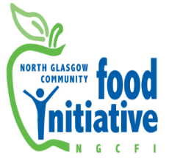

Royston Food Hub Manager

Supporting the local community and individuals in Royston, NE Glasgow through the provision of food education alongside improved access to community pantry, fruit and vegetables, and opportunities to take part in food growing activities. Using community development approaches, develop and maintain local food hub group activities aimed at reducing the impacts of food poverty, improving health and wellbeing and encouraging community led responses. Funded by The National Lottery Cost of Living Fund.

14 hours per week, (£27,304 pro rata) + 25 days Annual Leave & 12 Public Holidays pro rata + 7% pension contribution to 31st August 2024.

Closing Date: 23rd October 2023

Interviews: Monday 30th October 2023

To apply please send in a cover letter and CV to admin@ngcfi.org.uk

Full Details Following:

Registered charity number SC036842

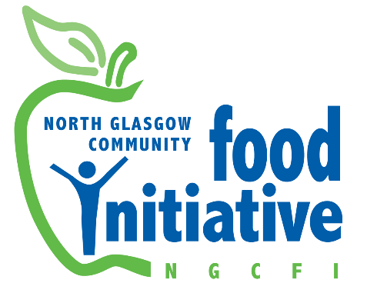

Job description

Post funding: Investing in Communities

Description of Role

In this role you will be responsible for maintaining and developing all areas of the work of the Royston Food Hub, supporting local communities and individuals through the provision of food education alongside improved access to fruit and vegetables, and opportunities to take part in growing activities.

Using community development approaches you will develop and maintain a programme of activities aimed at reducing the impacts of food poverty, improving health and wellbeing and encouraging community led responses.

You will take an active role in building partnerships and joint working with a range of organisations and groups to plan and deliver food based focused work, and you will have day to day responsibility for the running and development of services including Royston Community Pantry, community meals, healthy eating sessions, cookery classes, youth gardening and community growing.

Main Duties

Service Delivery

- Support the development, delivery and promotion of the Royston Community Pantry, including the development of this service and its partnerships.

- Work with the Community Cook and volunteers to plan, promote and deliver a programme of community meals, pop-ups and food based activities at the Roystonhill Community Hub (Spire View).

- Work with the Community Gardener to develop the Germiston allotment growing site as a space to deliver growing workshops and harvest to feed into food activities such as the Pantry, community meals and cookery classes

- Work with Sessional cooks to train and support the delivery of healthy cookery classes

- Working with colleagues to plan and deliver a programme of events and workshops including:

- Elementary Food Hygiene Training courses
- Volunteer celebration days and events
- Community events

- Developing and sustaining effective working relationships with the Royston Strategy Group, parent councils, community groups and statutory and non-statutory organisations, identifying new opportunities for joint working.

- Providing local leadership and coordination within the Food Hub area on activities and projects which address food poverty, hardship and destitution.

- Support the development of the Royston Food Hub Group, a steering group of local people, with a focus on community development principles.

- Coordinating the use of workshop space, introducing and maintaining systems to ensure it is used appropriately and safely with reference to all necessary regulations, including compliance with Health and Safety and food safety practices, the provision of risk assessments as required, and ensuring effective food handling and food hygiene standards are in place.

Communications

- Support the NGCFI communications strategy through the use of social media and other communications such as e-newsletters, flyers, leaflets, and posters to promote our services.

- Food dignity activities providing local people opportunities to engage in decisions such as fruit and veg available through the Barras or dishes cooked in Healthy eating classes.

Staff Support

- Working alongside Volunteer Coordinator to develop meaningful volunteering opportunities, including skills and capacity building training supporting community members to participate in Food Hub engagement activities.

- Supporting and Supervising staff including regular 1-2-1’s and 6 monthly appraisals

Administrative

- Establish and maintain effective planning, monitoring and evaluation processes to track the impact of attending NGCFI events and ensure funder requirements are met.

- Attend and participate in meetings, including staff meetings, as required.

- Provide regular written and verbal reports to Line Manager, Board of Directors or subcommittees, Community and Funders on the activities being undertaken.

- Maintain effective financial systems to comply with NGCFI financial policies and procedures and ensure activities stay within budgets, including recording income from sales and classes.
General
- Undertake any other relevant duties or projects delegated by the line manager which are in line with the responsibilities of the post.
Personal Development

- Attend local community events and network meetings events to represent NGCFI when required

- To comply with the NGCFI Handbook and policies therein.

- Keep up to date with good practice and legislation relevant to the role and service, including but not limited to Adult Protection, Data Protection, Confidentiality, Equalities and Health & Safety.

- Attend training and development opportunities in line with the overall needs of the organisation and individual, in particular to meet changing needs, new technology developments, and service requirements.

Person Specification
In your application you will be asked to demonstrate the following requirements, with specific examples for each.
(E)= Essential (D) - Desirable.
Qualifications
Educated to degree level in Nutrition or Dietetics, or a degree or HND in Community Development or similar. (E)
Advanced Food Hygiene Certificates and the ability to teach Elementary Food Hygiene Certificates; Health and Safety Training; First Aid Training. (D)
Knowledge
An understanding of the relationship between food, health and inequality. (E)
Understanding of the approaches set out in the Vision, Objectives and Aims of North Glasgow Community Food Initiative and how they relate to the Scottish policy landscape. (E)
Understanding of Community Development principles and asset building approaches. (E)
Abilities
Ability to deliver healthy eating workshops and in the absence of sessional cooks to deliver cookery classes. (E)
Group work facilitation skills (E)
Excellent communication skills including presentation skills, the use of social media, production of written materials and ability to convey complex information in an accessible way. (E)
Able to deliver multiple activities meeting varying funder requirements and deadlines, fulfilling multiple workplans. (E)
Ability to use standard office software including MS Word and Excel to produce reports, promotional materials and budget sheets. (E)
Experience
A minimum of sixth months experience working in a community setting. (E)
Experience of managing or supervising paid staff and / or volunteers. (E)
Experience of delivering needs assessment activities (D)
Experience of making successful funding applications (D)

Interpersonal Skills
Ensuring that knowledge is always appropriately shared and that communication is open and transparent. (E)
Good understanding of boundaries and confidentiality issues. (E)
Relationship Management
Building and Maintaining effective relationships with all relevant stakeholder in order to achieve NGCFI objectives. (E)
Managing relationships by being professional and co-operative, with a problem solving approach. (E)
Taking a proactive and solutions focused approach. (E)
Personal Qualities / Attitudes
Ability to work on own initiative, and equally well as a team member. (E)
Special Conditions
Clean UK drivers license and the ability to drive a van (E)
Willingness to become a member of the Protection of Vulnerable Groups Scheme. (E)

