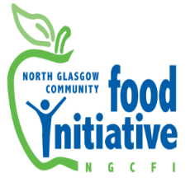
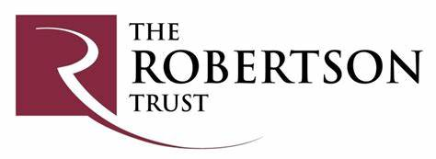

Springburn Community Cook

As a Community Cook you will be responsible for the organisation and delivery of food based activities including pop-up cafes, community meals and community focused workshops. You will be happy using your cooking skills to plan and prepare large meals using fresh produce, and able to share your skills and enthusiasm through the planning and delivery of cookery courses aimed at improving the cooking confidence and skills of local residents and their ability to make healthy food choices. You will develop classes and workshops which cover topics such as food waste reduction and cooking on a fixed budget, and will have an interest and enthusiasm for sharing diverse cooking cultures and traditions. Funded by The Robertson Trust.

7 hours per week, (£24,101 pro-rata) + 25 days Annual Leave & 12 Public Holidays pro rata + 7% pension contribution to 31st August 2026.

Closing Date: 23rd October 2023

Interviews: 30th October

To apply please send in a cover letter and CV to admin@ngcfi.org.uk

Full Details Following:

Registered charity number SC036842

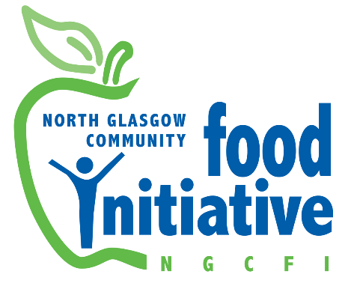

Job description

Job title: Community Cook, Springburn

Employer: North Glasgow Community Food Initiative

Salary: 7 hours per week, (£24,101 pro rata) to 31st August 2024

Working hours & pattern:

Location: Springburn Food Hub

Responsible to: Springburn Food Hub Manager

Responsible for: Volunteers

Post funding: The Robertson Trust

Description of Role

As a Community Cook you will be responsible for the organisation and delivery of food based activities including pop-up cafes, community meals, and community focused workshops. You will be happy using your cooking skills to plan and prepare large meals using fresh produce, and able to share your skills and enthusiasm through the planning and delivery of cookery courses aimed at improving the cooking confidence and skills of local residents and their ability to make healthy food choices. You will develop classes and workshops which cover topics such as food waste reduction and cooking on a fixed budget and will have an interest and enthusiasm for sharing diverse cooking cultures and traditions.

Main Duties

Service Delivery
- Planning, preparing and serving regular community meals, in consultation with the staff supporting the Community Garden and the Barras, using seasonal fresh produce from NGCFI as the main components, and buying the other necessary ingredients.

- Working alongside other services to plan and deliver pop-up cafes and events supporting community activities, showcasing the use of fresh fruit and vegetables from NGCFI.

- Delivering REHIS Elementary Food Hygiene training for volunteers, staff and members of the local community, supporting the development of food focused activities and events.

Communications

- Supporting the NGCFI communications strategy by contributing recipes and cooking tips, as well as some descriptive content and photographs from classes and events, to be used on NGCFI social media and other communications such as the Community Food Newsletter, e-newsletters, leaflets, and posters to promote our services.

Staff Support

- Liaising with the Food Hub Manager and Volunteer Coordinator to support and develop volunteer involvement in cooking activities.

- Coordinate volunteer and sessional staff involvement in events, including training and pre- and post-event de-briefs.

Administrative

- Maintaining records of attendance at classes, issuing participant reminders for next sessions.

- Maintaining financial records tracking income and expenditure for events and classes.

- Providing recipes for each session and collated at the end of the course.
- Undertaking and recording risk assessments for each activity area, maintaining up to date records, and ensuring all health and safety policies and procedures are followed.

- Recording and compiling evaluation records including equal opportunities monitoring, and compiling regular reports summarising these for each event.

General
- Undertake any other relevant duties or projects delegated by the line manager which are in line with the responsibilities of the post.
Personal Development

The duties described here are indicative of the kind of work we want, and not contractual or to be regarded as exhaustive. As the Food Hub develops, they may change and also be subject to review as a result of changes in funding or funders' requirements. The postholder may be required to undertake other duties as required.

Person Specification

(E)= Essential (D) - Desirable

Knowledge
- An understanding of the relationship between food, health and inequality. (E)
- A demonstrable understanding of the importance of food as a link to culture, particularly for minority communities. (E)
- Understanding of the approaches set out in the Vision, Objectives and Aims of North Glasgow Community Food Initiative. (E)
Abilities
- Well organised with an ability to plan and deliver cookery classes enthusiastically, focused in healthy eating and sharing cooking skills to young people and adults (E)
- An ability to enthuse and encourage an interest in food and cookery with people of all levels of skill and ability. (E)
Experience
- Experience of and proficient in delivering healthier eating cookery classes (E)
- Experience of using monitoring and evaluation tools (E)
- Experience of using and working within appropriate protocols and procedures eg. health and safety, risk assessments. (E)
- Experience of supporting volunteers or managing staff (D)
Qualifications
- Food Hygiene Certificate (E)
- Qualification or suitable relevant experience in food and nutrition (D)
- Food & Health Certificate (D)
- Emergency First Aider Certificate (D)
Interpersonal Skills
- Excellent verbal communication skills and ability to communicate effectively with a diverse range of people. (E)
- Ability to work on own initiative, and equally well as a team member. (E)
- Experience of supporting people with higher support needs, eg: those with learning difficulties or mental health issues. (D)
Personal Development

- Commitment to comply with the NGCFI Handbook and policies therein. (E)
- Keep up to date with good practice and legislation relevant to the role and service, including but not limited to Safeguarding Children, Adult Protection, Data Protection, Confidentiality, Equalities and Health & Safety. (E)
- Attend training and development opportunities in line with the overall needs of the organisation and individual, in particular to meet changing needs, new technology developments, and service requirements. (E)

Special Conditions
- Clean UK drivers license and access to a vehicle (E)
- Willingness to undergo PVG check (E)

