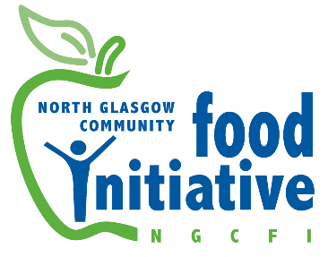
Job Description
Job Title: Sessional Van Delivery Driver (Flexible Working)
Employer: North Glasgow Community Food Initiative Board of Directors
Hourly Rate: £18 per hour
Contract Type: Sessional (contract provided including paid holiday entitlement)
Hours: As required, flexible working – including early mornings, occasional evenings, and weekend events.
Annual Leave: Statutory minimum entitlement paid in lieu of leave not taken
Responsible to: Food Hub Manager / Milton Garden Manager
Base: North Glasgow area – including Royston, Milton, Springburn, and surrounding partners
Job Purpose:
To provide reliable and safe transportation for fruit and vegetable deliveries, collections from suppliers and donors, and distribution of goods across NGCFI hubs and partner organisations. The role also requires representing NGCFI professionally while engaging with customers, partners, and volunteers during collections and deliveries.
Main Duties and Responsibilities:
- Collect and return NGCFI’s hire van from the designated vehicle hire provider.
- Carry out early morning collections of fresh produce from the Fruit Market.
- Deliver orders (e.g. to Rosemount Lifelong Learning, local libraries, and other partners).
- Transport fresh produce, equipment, and supplies between NGCFI’s food hubs and pop-up sale venues.
- Support occasional event logistics by transporting goods and materials.
- Carry out moderate to heavy lifting during loading and unloading of deliveries.
- Maintain high standards of health and safety while driving and loading.
- Ensure timely and safe delivery of all items, reporting any issues to line manager.
- Liaise with staff, volunteers, and partners in a friendly and respectful manner, promoting NGCFI’s values.
- Return vehicle by 5pm to the hire provider unless otherwise authorised.
- Work in accordance with NGCFI’s policies, including those relating to safeguarding, health & safety, manual handling, and customer service.
- Maintain a basic record of delivery routes and times as needed for evaluation and funding reports.
- Participate in any required training, support sessions, or evaluations.
- Carry out any other reasonable duties as required in support of NGCFI’s mission.

Person Specification
Essential Criteria:
- Full, clean UK driving licence
- Physical ability to safely lift and carry boxes of produce
- Good interpersonal skills and ability to engage with a range of people (including asylum seekers, volunteers, and community groups)
- Experience or willingness to work flexibly, occasionally including evenings or weekends
- Ability to carry out basic arithmetic and handle small amounts of cash
- Commitment to NGCFI’s ethos, values, and community-focused aims
- Willingness to undergo a PVG/Disclosure Scotland check
- Willingness to complete Manual Handling training
Desirable Criteria:
- Experience in a similar delivery or community-based driving role
- Basic understanding of food distribution, community health, or sustainable local food systems
- Familiarity with North Glasgow’s local areas and road networks

